D2 Subsystems

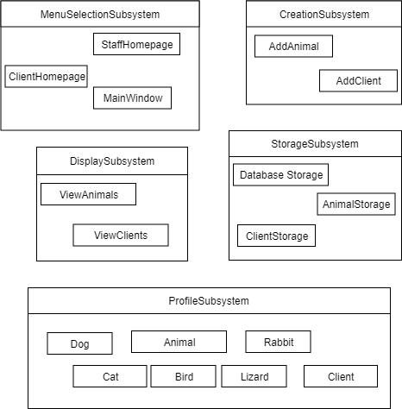

**MenuSelectionSubsystem**

* The MenuSelectionSubsystem for allowing the user to choose how they want to interact with the system.

MainWindow

* Responsible for letting the user decide if they want to log in to StaffHomepage or ClientHomepage. Checks for valid email if user is trying to log in as an existing Client.

StaffHomepage

* Allows the user to initiate the Animal/Client creation process. Allows the user to initiate the viewing of all Animals and Clients.

ClientHomepage

* Allows the user to view all Animals.

**CreationSubsystem**

* The CreationSubsystem is responsible for creating Animal and Client profiles. It is this subsystem that gathers all of the users’ inputs and stores them in new objects.

AddAnimal

* Gets all required information from the user and creates a new Animal object.

AddClient

* Gets all the required information from the user and creates a new Client object

**DisplaySubsystem**

* The Display subsystem is responsible for viewing all the Animals and Clients in the StorageSubsystem.

ViewAnimals

* Displays all animals in the StorageSubsystem along with all their attributes. Users are able to filter results by Animal species.

ViewClients

* Displays all clients in the StorageSubsystem along with their contact information.

**StorageSubsystem**

* Responsible for local and persistent storage of all Animal and Client objects. Responsible for assigning unique Animal and Client id’s.

AnimalStorage

* Responsible for storing all 5 species of Animal objects created by AddAnimal. Once AnimalStorage assigns id Animal object information is added to DatabaseStorage.

ClientStorage

* Responsible for storing the Clients. Once ClientStorage assigns a unique id the Client information is added to DatabaseStorage.

DatabaseStorage

* Persistent storage for all Animal and Client attributes. Used by MainWindow at startup to create new Animal/Client objects from database data.

**ProfileSubsystem**

* Responsible for locally storing information entered by the user in the form of Animal or Client objects.

Animal

* Includes 5 subclasses (Dog, Cat, Bird, Lizard, Rabbit). Used to store information input by user regarding Animals in the shelter. These are then stored in AnimalStorage.

Profile

* Used to store information input by user regarding their own profile. These are then stored in ClientStorage.